GUIDE FOR STORAGE OF WARE POTATO
ONLY STORE THE BEST POTATOES
Storing quality potatoes begins in the field during the growing season
- Only store good quality potatoes. If any potatoes are rotting, damaged or coming from diseased fields, these potatoes must be eaten or sold at harvest
- Storing only a few rotten potatoes can result in great losses in storage
- During the growing season, mark areas infected with bacterial wilt to avoid storing potatoes harvested from these infected areas
- Do not store potatoes from plants infected with bacterial wilt, these potatoes should be sold right after harvest
Potato infected with bacterial wilt
- Do not store potatoes that have been damaged during
harvest or are starting to rot, these potatoes should be sold right after harvest
Harvest practices for better storability
- Only store potatoes harvested from mature plants
- De-haulm plants 10 – 15 days before harvesting
- De-haulming is killing the plant above the soil – usually by cutting the stem at the soil line
- De-haulming is essential if potatoes are to be stored as this allows the skin to thicken to protect from handling and transport injury, as well as postharvest diseases
- De-haulm during dry conditions
Potato plants after de-haulming
- Harvest potatoes gently, most injury to potatoes
occurs during harvest
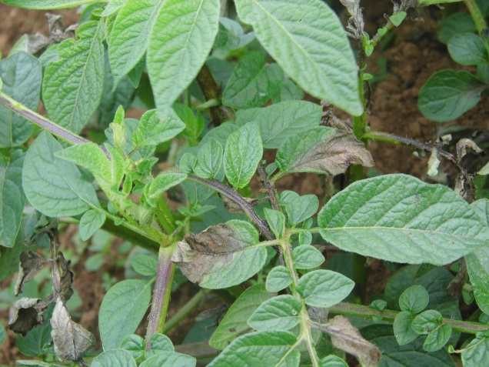
In case of late blight infection
- If a crop shows symptoms of late blight it is important to avoid storage of the potatoes becoming infected with late blight
- De-haluming will assist to stop potatoes from becoming infected with late blight
- If a crop is infected with late blight, de-haulm when 20 – 25% of foliage is killed by late blight
- Potatoes infected with late blight can rot in storage
Potato infected with late blight
HOW TO STORE POTATOES INSIDE THE STORES
- After following the good practices of the previous page, it is still important to select good quality potatoes for storage and remove all rotten, damaged and diseased potatoes
- DO NOT STORE ANY POTATOES SUSPECTED OF BEING ROTTEN, DISEASED OR DAMAGED
- Keep potatoes in the dark to slow down sprouting → exposure to light promotes sprouting
- Monitor stored potatoes regularly and remove all rotten potatoes and those adjacent to any rotten potatoes
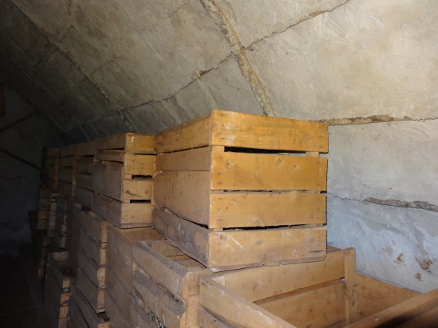
Crates
- Store in crates if possibility of rotten or damaged potatoes. Thus if some potatoes are rotten the crates will limit the spread of rot to more potatoes in the store
- Crates also make it easier to trace when different harvest lots are put in the store
- Suitable for long term storage, 2 – 3 months
Bulk
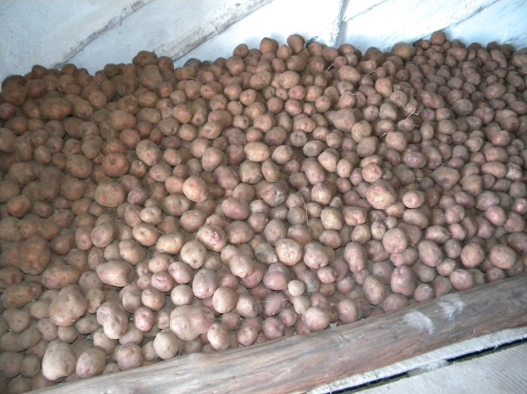
- Potatoes can be bulk stored if all potatoes are of good quality and there is low risk of a few rotten potatoes creating a rotten nest in the middle of the piles
- A bulk pile up to 2 m in height
- Bulk piles can be right up to the walls, no need to leave a space between the pile and a wall
- Bulk piles are suitable when it is not necessary to trace certain potatoes to a harvest lot or owner
- Suitable for long term storage, 2 – 3 months
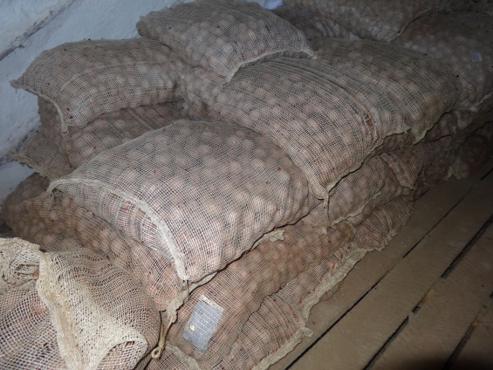
Bags
- Potatoes should only be stored in bags for short term storage, maximum to 3 weeks
- Store bags upright, not on their side
- Only store good quality potatoes in bags
- Bags restrict air flow thus if a rotten potato is in the bag, the remaining potatoes can rot quickly
Contact BUGIZARDI for more information +256 782 427 527

